| **Event:**  **Latitude**:  **Longitude**:  **Address**:  **Type of structural collapse**:  **Building footprint area:**  **Max. collapse distance:**  **Max. Debris distance:**  **Building Material:**  **Structural system:**  **# of stories:**  **Approximate total height:**  **Apparent irregularities:**  **Approximate construction date:** | 2011 Christchurch earthquake  -43.527476  172.638904  233 Cambridge Terrace, Christchurch  Pancake  670 m2 (square)  10 m  25 m  Reinforced concrete  RC frame with a RC wall  5  20 m  Non-ductile detailing  1963-64 |
| --- | --- |

**BEFORE**

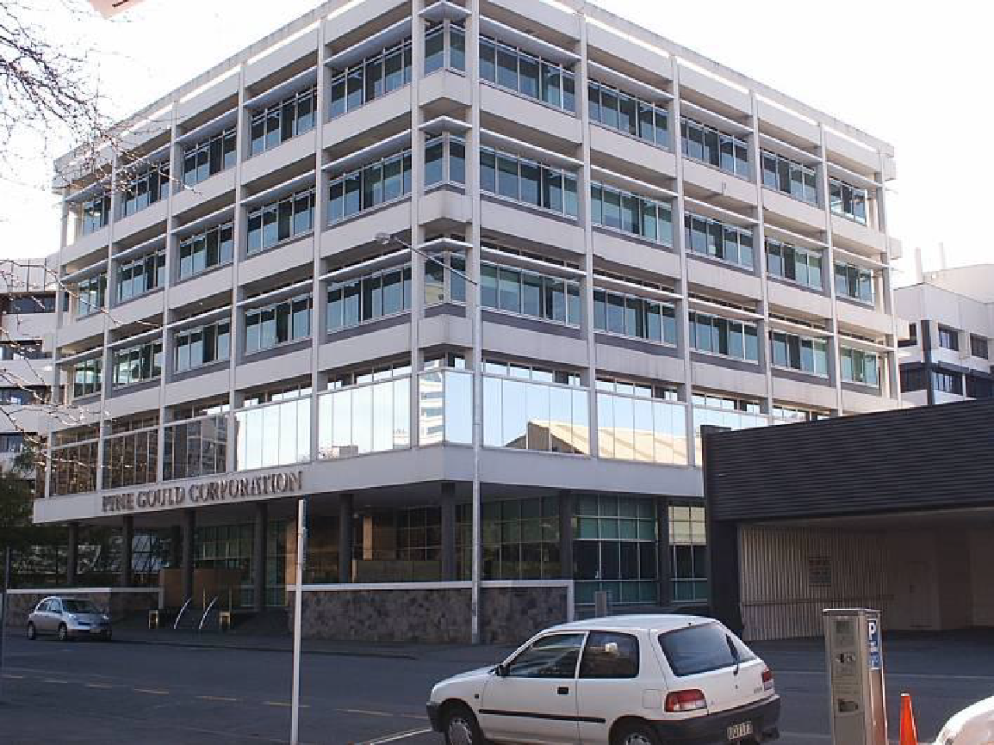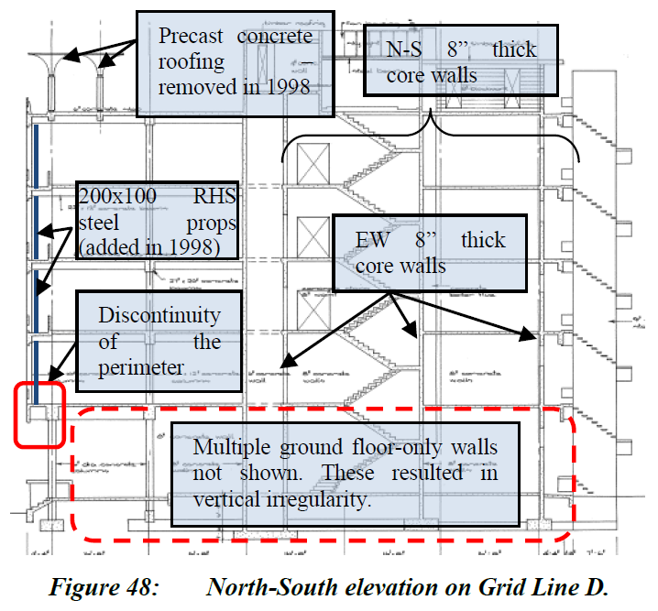

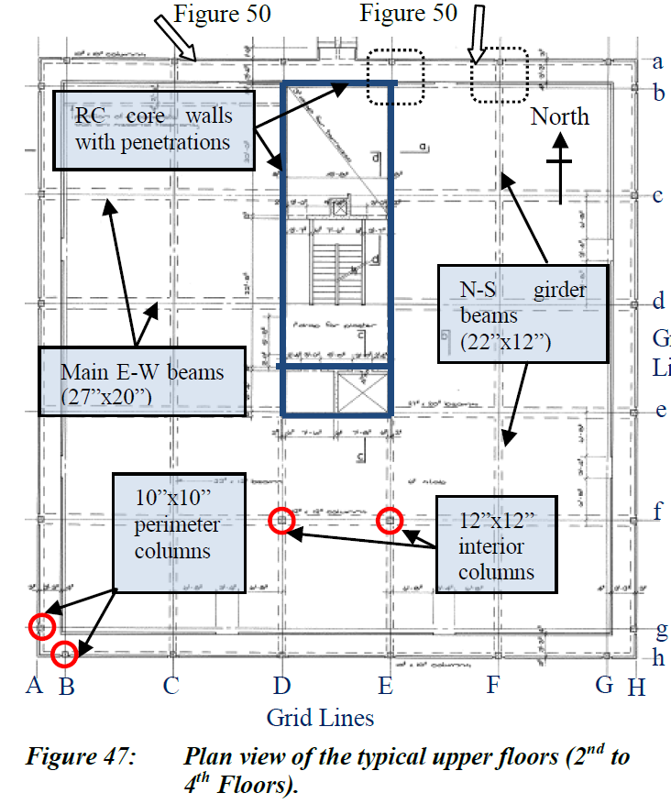 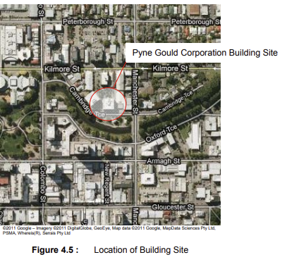

**AFTER**

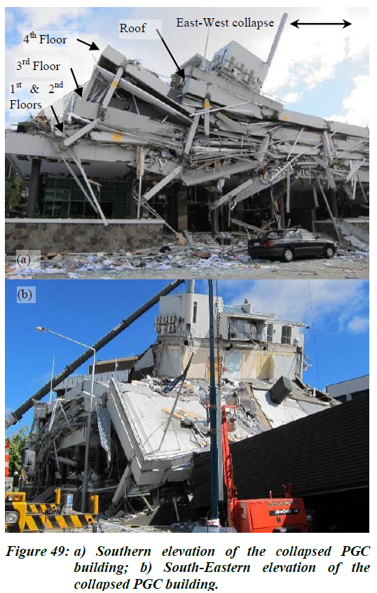 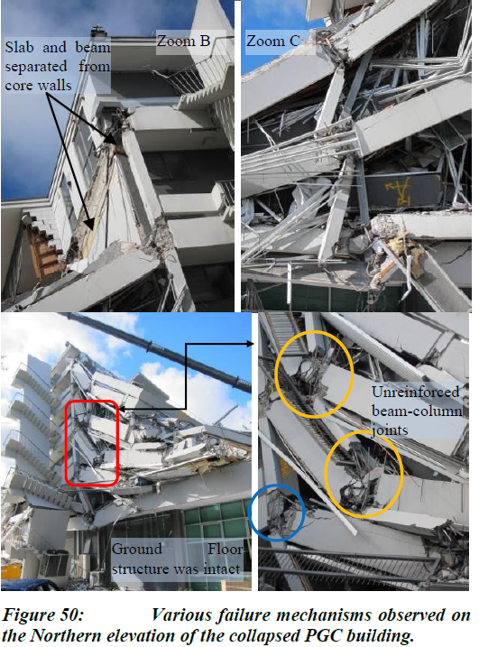

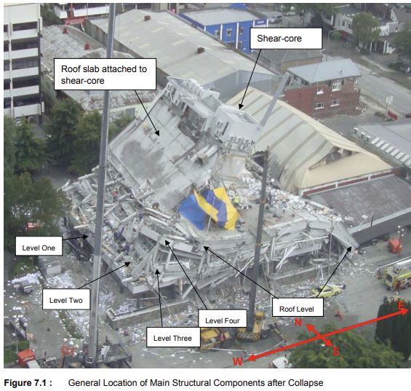

(Kam et al. 2011) (Beca, 2011)

| **Event:**  **Latitude**:  **Longitude**:  **Address**:  **Type of structural collapse**:  **Building footprint area:**  **Max. collapse distance:**  **Max. Debris distance:**  **Building Material:**  **Structural system:**  **# of stories:**  **Approximate total height:**  **Apparent irregularities:**  **Approximate construction date:** | 2011 Christchurch earthquake  -43.532899  172.642495  249 Madras St  Rubble Pile or Implosion  690 m2 (rectangular)  10 m  25 m  Reinforced concrete  Precast RC frame with a RC core and RC coupled wall  6  20 m  Torsional irregularity  Mid 1980s |
| --- | --- |

**BEFORE**

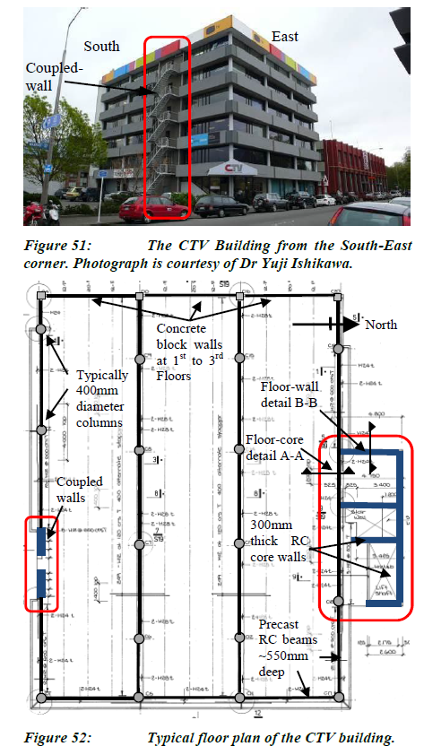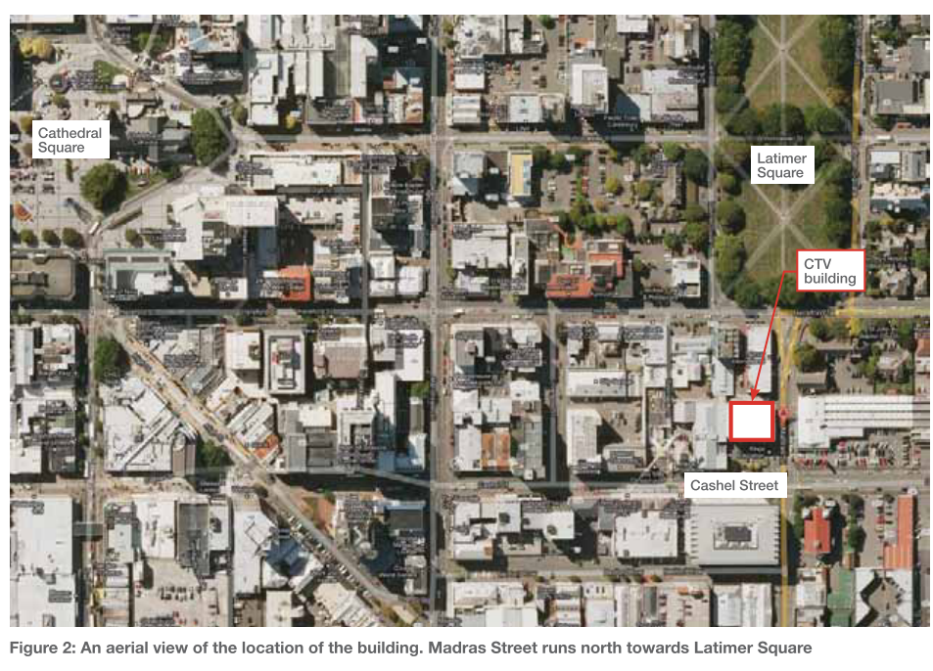

**AFTER**

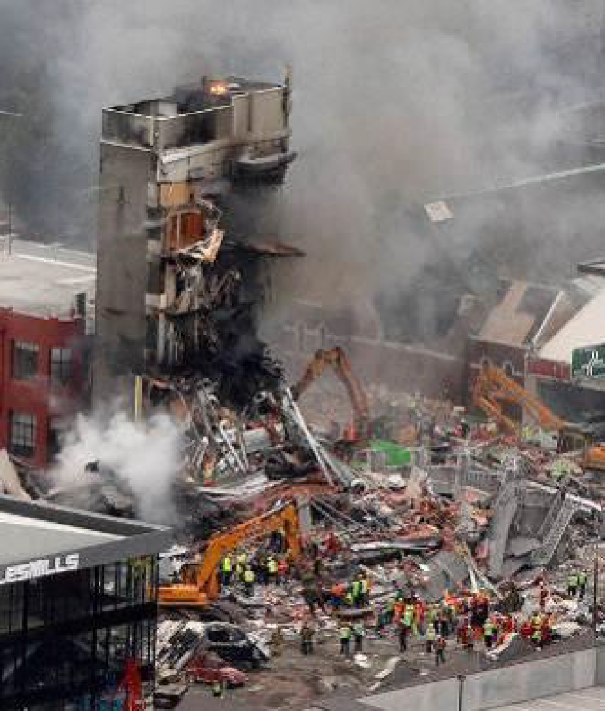 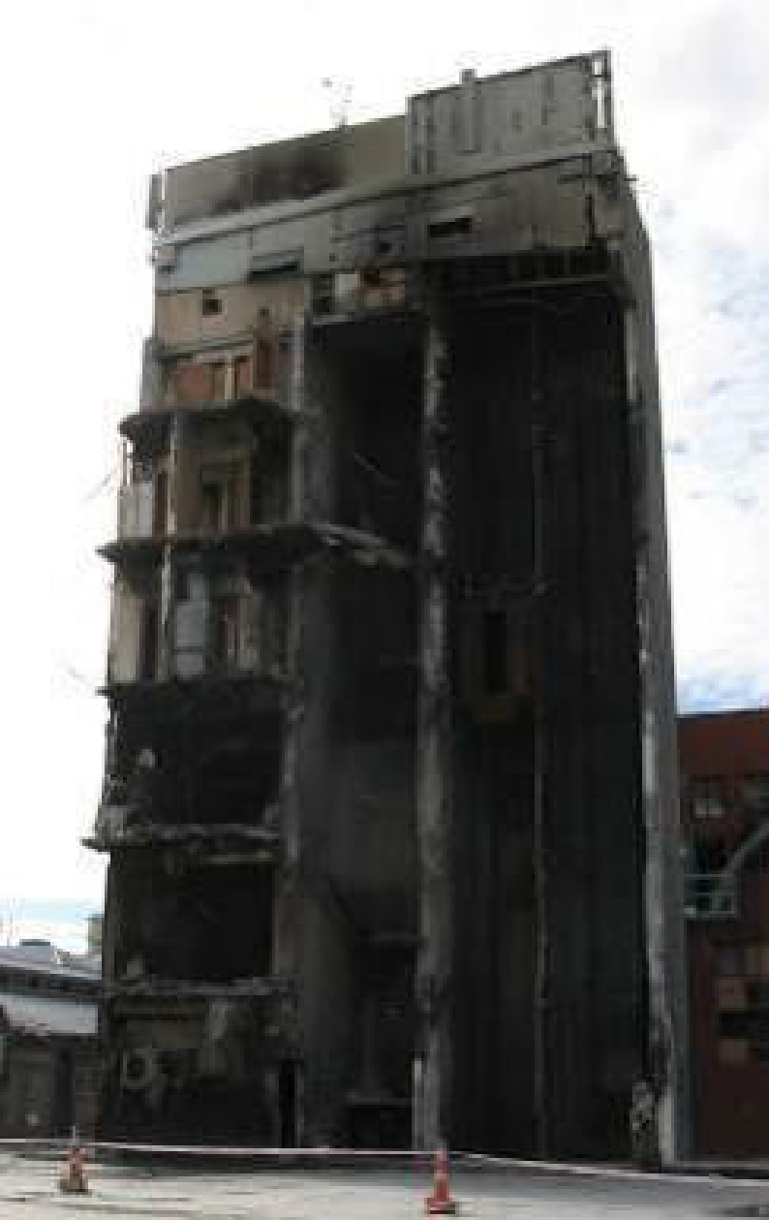

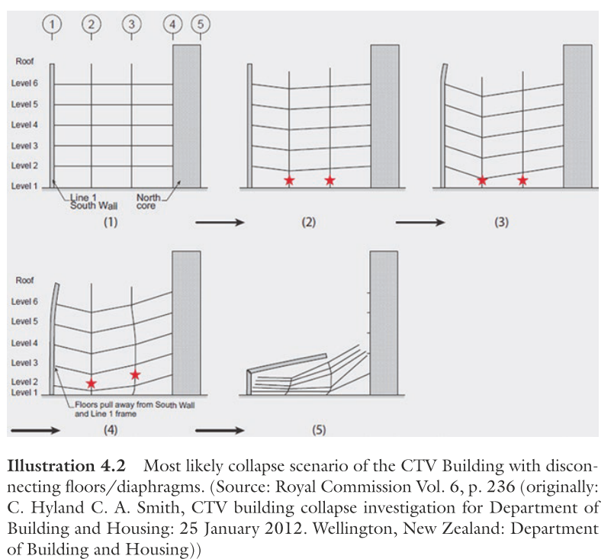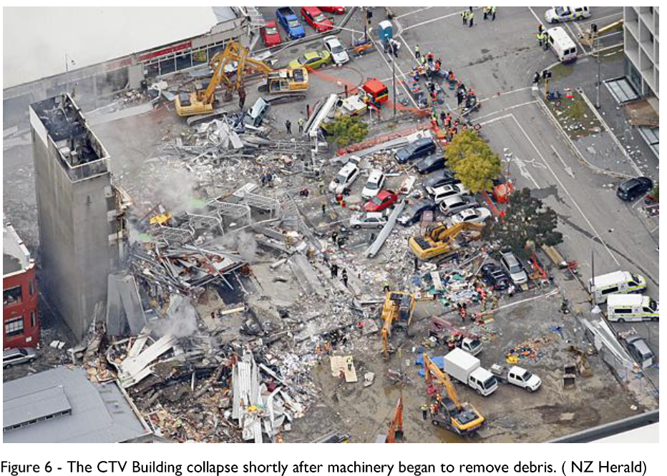

(Kam et al. 2011) (Seible, 2022)

(<https://canterbury.royalcommission.govt.nz/Final-Report-Volume-Seven-Contents>)

(Hyland and Smith, 2012)

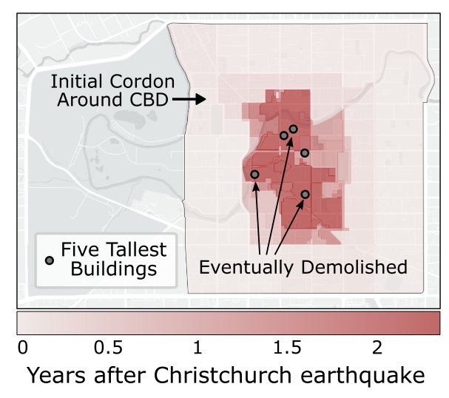 (Hulsey and Deierlein, 2022)

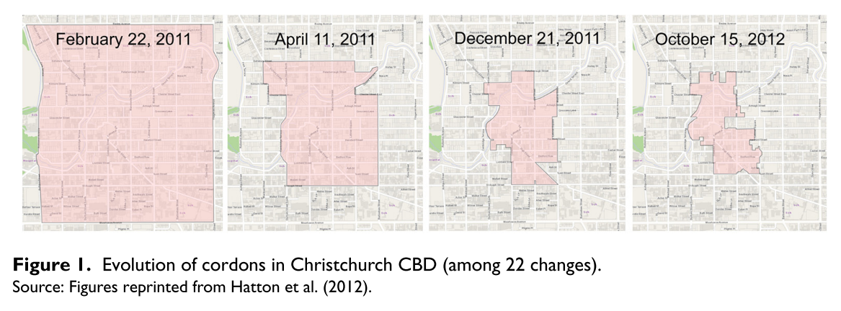 (Shrestha et al. 2022)